GB-Nolan Chart – Visual Specification
This visual is intended to be a Groupbuild-ified update to the Nolan Chart, which appears at:
- https://www.conceptdraw.com/solution-park/infographics-politics, and also at,
- https://www.reddit.com/r/worldbuilding/comments/169b82d/major_political_ideologies_of_the_43rd_century/.
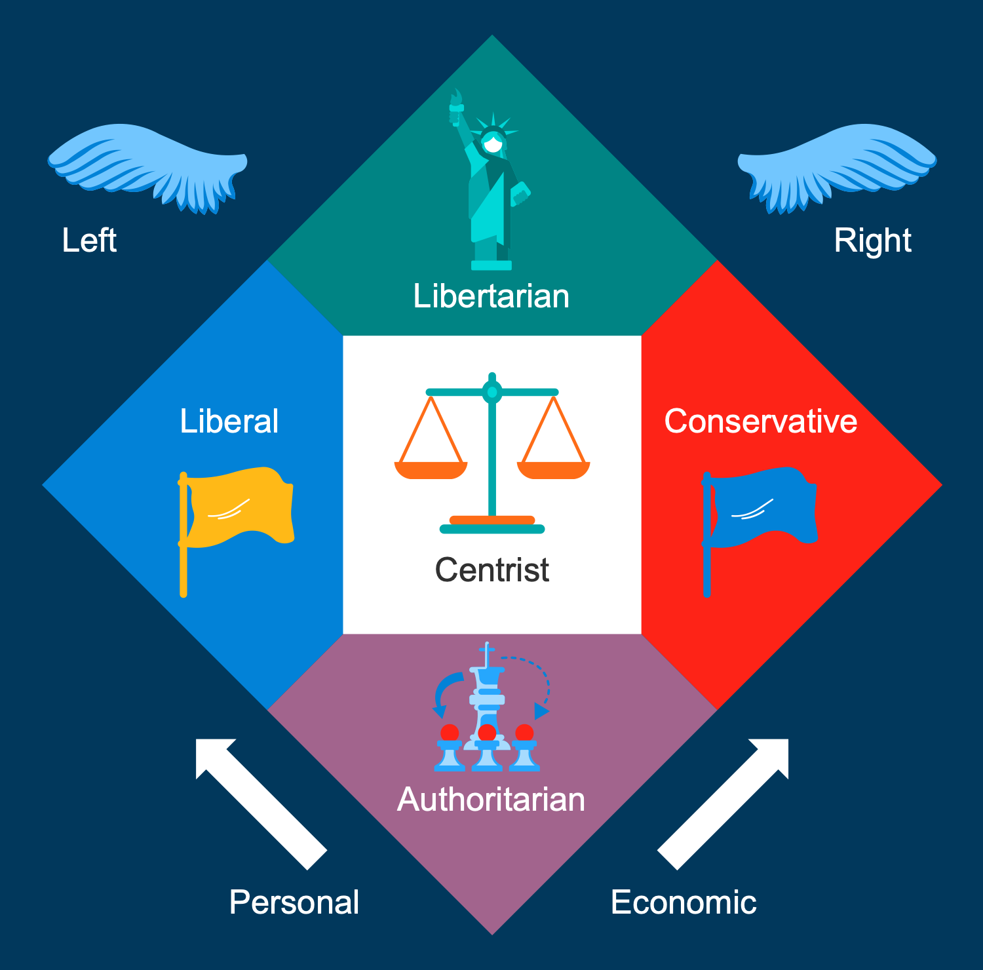
A subsequent version of this document will serve as a prompt for graphical generative-AI.

Overall Layout
Shape: Four diamond orientation quadrants under a square top-center.
Background: Entire chart sits on a transparent (clear) background.
Outline: Text and icons over clear areas have thin black visibility-outline.

Center Quadrant: Centrist
Background: Solid Green (medium tone, distinguishable from other areas).
Icon: Balance scale, left arm blue, right arm red. Scale's structure should be neutral (gray or black) with a thin black outline.
Text: “Centrist” (centered, white font with thin black outline).

Left Quadrant: Liberal
Background: Dark Blue (use this same blue consistently across all blue-themed elements).
Icon: White waving flag on a pole, stylized with sharp lines.
Text: “Liberal” (white font, thin black outline).

Right Quadrant: Conservative
Background: Red (match branding, avoid orange tint).
Icon: White waving flag, same style as Liberal quadrant.
Text: “Conservative” (white font, thin black outline).

Bottom Quadrant: Authoritarian
Background: Distinct (suggested: Deep purple or dark gray-blue).
Icon: White group of stylized people under a gear or command symbol.
Text: “Authoritarian” (white font, two lines if needed, thin black outline).

Top Quadrant: Libertarian
Background: Different (suggested: Teal or golden yellow).
Icon: White minimalist Statue of Liberty or torch symbol.
Text: “Libertarian” (white font, thin black outline).

Top Right Icon: Republican Party
Icon: Stylized white elephant with three white stars across its back.
Outline: Thin black outline around elephant and stars.
Background: Clear.

Top Left Icon: Democratic Party
Icon: Stylized white donkey with three white stars across its back.
Outline: Thin black outline around donkey and stars.
Background: Clear.

Bottom Corner Labels (Directionals)
Replace “Personal” with two-line label: “Focus on Social Policies”.
Replace “Economic” with two-line label: “Focus on Economic Policies”.
Font: White, bold, with thin black outline.
Arrows: DELETE both directional arrows.

Style Consistency
Icons should follow flat, vector-like style using simplified forms.
Colors must be bold and high contrast, suitable for dark-mode websites.
Text must be legible at small sizes and maintain clarity when scaled.

